Binary Synchronous Communications Protocol (BISYNC)

Byte Oriented approach

1. It simply views the frame as a collection of bytes or characters. (It is also called as character oriented approach)
2. 3 protocols:
   1. BISYNC : Binary Synchronous Communications Protocol
   2. PPP: Point to Point protocol
   3. DDCMP: Digital Data communication message protocol

BISYNC:

1. Data layer protocol
2. It is a sentinel approach
3. Developed by IBM
4. Also preferred as BSC.
5. Byte oriented protocol
6. Frame format
   1. 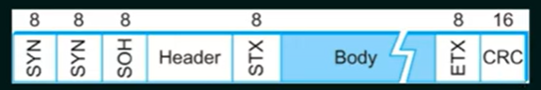
   2. Frames transmitted beginning with leftmost field
      1. Beginişng of a frame is denoted by sending a special SYN (synchronize) character
      2. Data portion of the frame is contained between special sentinel character STX (start of text) and ETX (end of text)
      3. SOH: Start of header
      4. DLE: Data Link Escape
      5. CRC: Cyclic Redundancy Check
      6. Similar problem to bit oriented like characters in stx can happen in the body. How to handle it?:
         1. Charter Stuffing (Byte stuffing):
            1. Byte stuffing is the process of adding one extra byte whenever there is a flag or escape character in the text.
            2. This is done by DLE in BISYNC.